Denis Iurchak

Data analysis 4. Assignment 2

**Data**

The data I analyzed includes GDP per capita in PPP (constant 2017 dollars) and CO2 emissions per capita for all world countries between 1992 and 2018. The dataset includes 4516 observations.

I dropped 848 missing data points from the dataset. I also dropped 13 countries that had less than 16 years with present data. I chose a threshold of 16 because for me it seemed reasonable. After dropping the missing values and countries with poor coverage, years 1993, 2017 and 2018 disappeared from the dataset.

**Findings**

The cross-section models for two separate years, 2000 and 2015, show that, on average, every 1 p.p. increase in GDP per capita tends to be followed by a 0.14 p.p. increase in per capita CO2 emissions, controlling for a country. Other models, which compare countries over time and within the cross-sectional units, estimate the average increase in per capita CO2 emissions at approximately 0.65 p.p., on average, for a 1 p.p. higher GDP per capita.

The potential mechanism can be as follows. As per capita GDP grows, the consumption and industrial production increases, which leads to higher CO2 emissions.

The ‘cleanness’ of industrial production can be a confounder. Dirtier industrial production can cause a lot of emissions but also increase GDP fast. Cleaner industrial production can have lower emissions, but also be less effective at increasing GDP.

**Regressions**

1. Cross-section OLS

The per capita CO2 emissions were 0.132 p.p. higher, on average, in 2000 for every 1 p.p. increase in GDP per capita, controlling for a country.

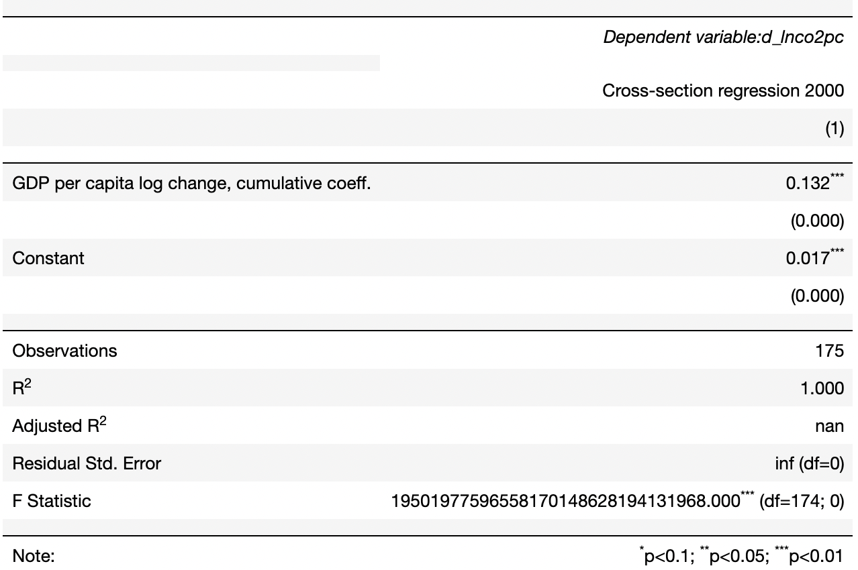

1. Cross-section OLS for 2015

The per capita CO2 emissions were 0.149 p.p. higher, on average, in 2015 for every 1 p.p. increase in GDP per capita, controlling for a country.

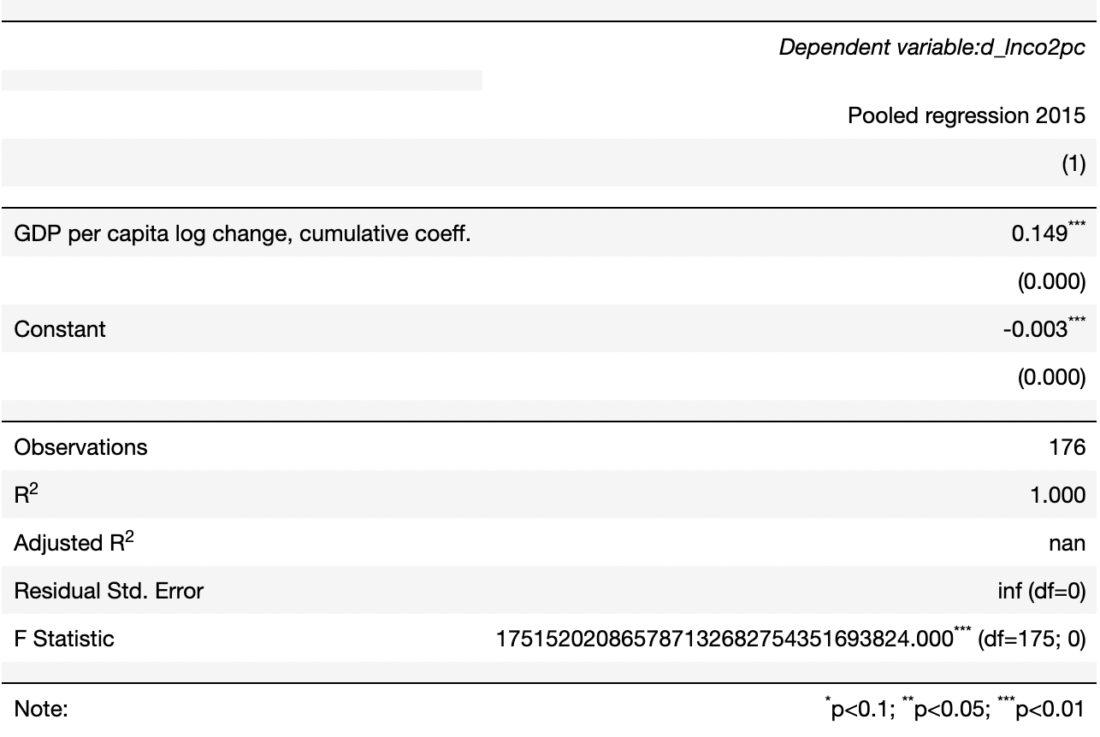

1. First difference model, with time trend, no lags

A 1 p.p. increase in GDP per capita tends to be followed by 0.61 p.p. increase in CO2 emissions per capita, on average, in the data, relative to the country trend.

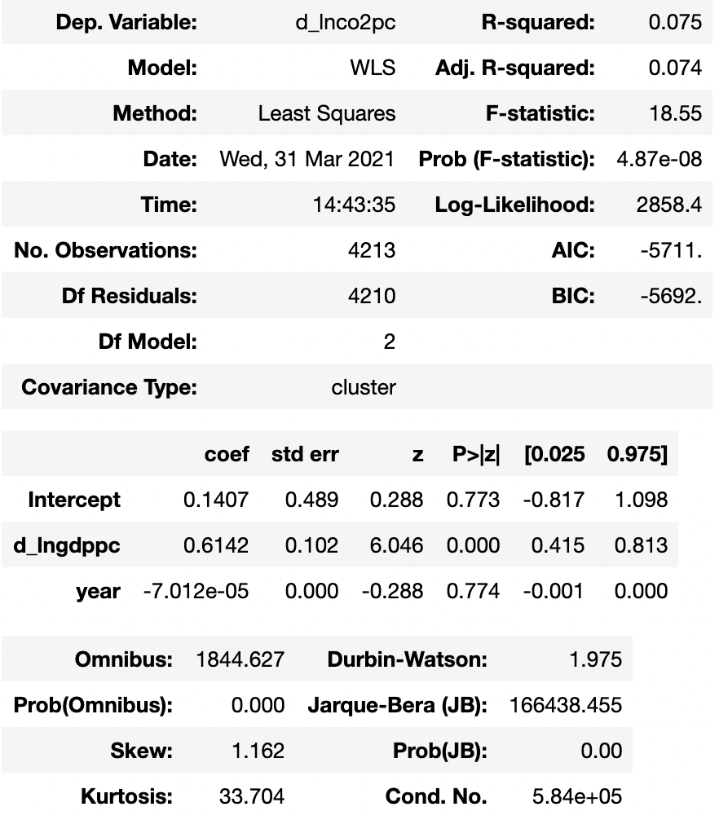

1. First difference model, with time trend, 2 year lags

A 1 p.p. increase in GDP per capita tends to be followed by 0.62 p.p. cumulative increase in CO2 emissions per capita, on average, within two years in the data, relative to the country trend.

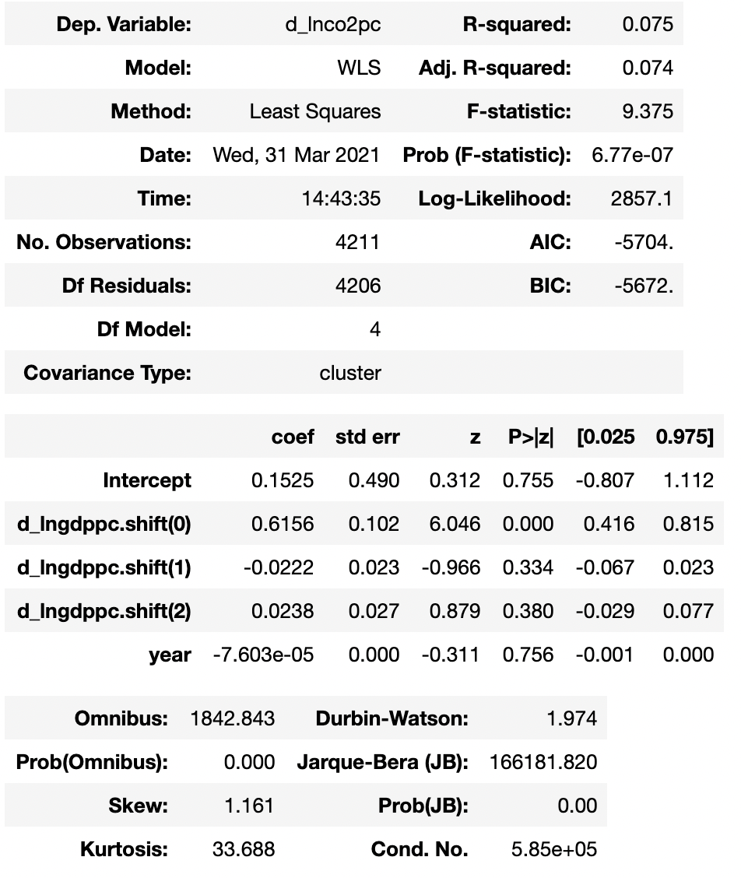

1. First difference model, with time trend, 6 year lags

A 1 p.p. increase in GDP per capita tends to be followed by 0.55 p.p. increase in CO2 emissions per capita, on average, within six years in the data, relative to the country trend.

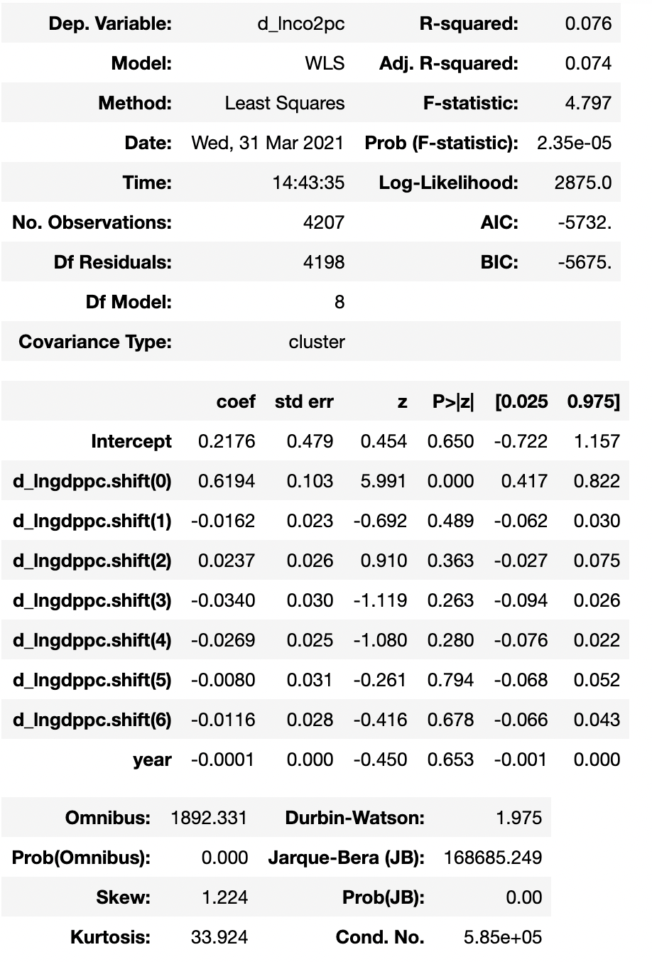

1. Fixed effects model with time and country fixed effects

Per capita CO2 emissions tend to be 0.75 p.p. higher, on average, for a 1 p.p. increase in per capita GDP within the data, compared to mean per capita CO2 emissions for a country and within a given year.

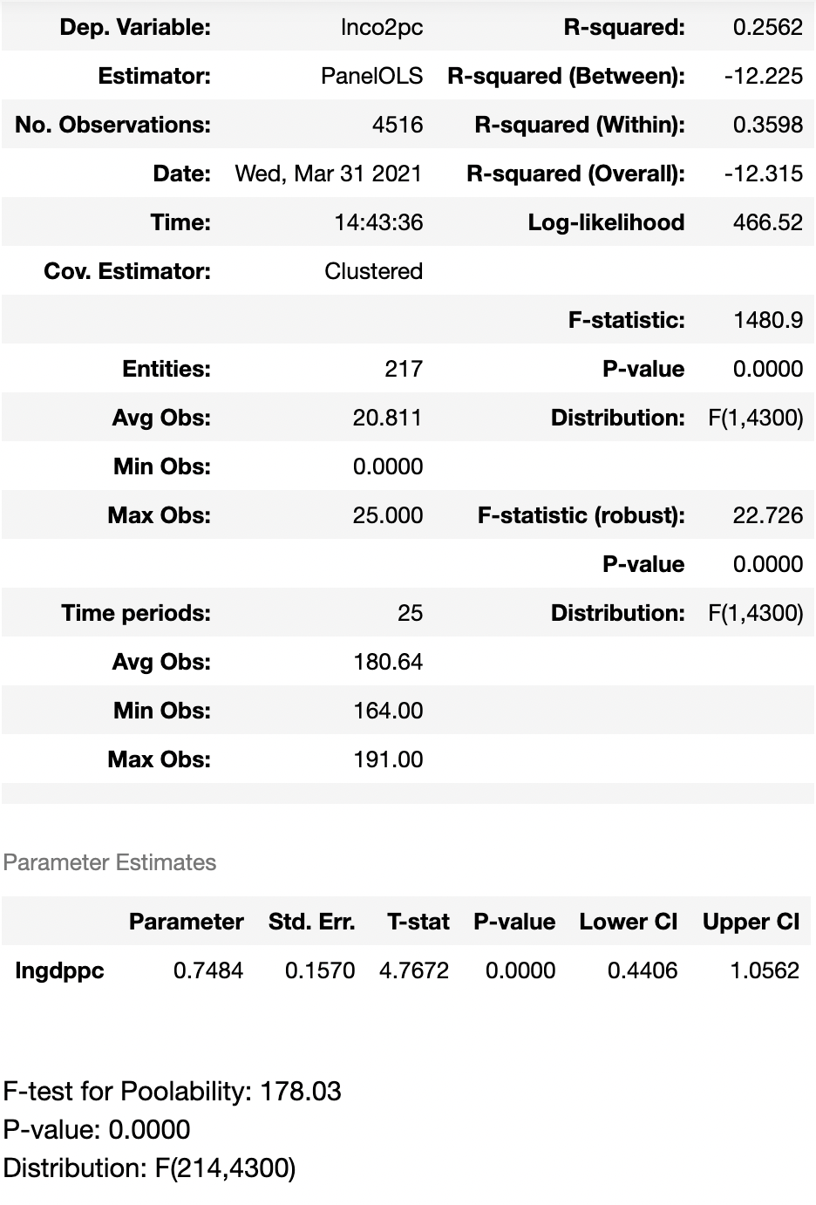

1. Long difference

A 1 p.p. increase in GDP per capita tends to be followed by 0.68 p.p. increase in CO2 emissions per capita, on average, between 1993 and 2016 in the data.

